# Difference between various OS based on Kernels

| **Sr. No.** | **Key** | **Operating System** | **Kernel** |
| --- | --- | --- | --- |
| 1 | Type | Operating system is a system software. | Kernel is a part of operating system. |
| 2 | Work | Operating system acts as an interface between user and hardware. | Kernel acts as an interface between applications and hardware. |
| 3 | Main tasks | Ease of doing system operations, security etc. | Memory management, space management, process management and task management. |
| 4 | Basis | A computer need Operating System to run. | An Operating System needs Kernel to run. |
| 5 | Types | Operating Systems types are multiuser, multitasking, multiprocessor, realtime, distributed etc. | Kernel types are monolithic kernel and micro kernel. |
| 6 | Boot | Operating System is the first program to load when computer boots up. | Kernel is the first program to load when operating system loads. |
| 7 | Purpose | Kernel memory management, process management, task management, disk management. | In addition to the responsibilities of Kernel, Operating System is responsible for protection and security of the computer. |

# CPU Scheduling Algorithm

A Process Scheduler schedules different processes to be assigned to the CPU based on particular scheduling algorithms. There are six popular process scheduling algorithms −

These algorithms are either **non-preemptive** or **preemptive**. **Non-preemptive** algorithms are designed so that once a process enters the running state, it cannot be preempted until it completes its allotted time, whereas the **preemptive** scheduling is based on priority where a scheduler may preempt a low priority running process anytime when a high priority process enters into a ready state.

1. **First Come First Serve (FCFS)**

* Jobs are executed on first come, first serve basis.
* It is a non-preemptive, pre-emptive scheduling algorithm.
* Easy to understand and implement.
* Its implementation is based on FIFO queue.
* Poor in performance as average wait time is high.

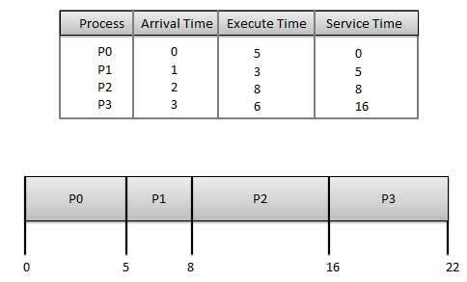

Wait time of each process is as follows −

|  |  |
| --- | --- |
| **Process** | **Wait Time: Service Time - Arrival Time** |
| P0 | 0 - 0 = 0 |
| P1 | 5 - 1 = 4 |
| P2 | 8 - 2 = 6 |
| P3 | 16 - 3 = 13 |

Average Wait Time: (0+4+6+13) / 4 = 5.75

1. **Shortest Job Next (SJN)**

* This is also known as shortest job first, or SJF
* This is a non-preemptive, pre-emptive scheduling algorithm.
* Best approach to minimize waiting time.
* Easy to implement in Batch systems where required CPU time is known in advance.
* Impossible to implement in interactive systems where required CPU time is not known.
* The processer should know in advance how much time process will take.

Given: Table of processes, and their Arrival time, Execution time

|  |  |  |  |
| --- | --- | --- | --- |
| **Process** | **Arrival Time** | **Execution Time** | **Service Time** |
| P0 | 0 | 5 | 0 |
| P1 | 1 | 3 | 5 |
| P2 | 2 | 8 | 14 |
| P3 | 3 | 6 | 8 |

Waiting time of each process is as follows −

|  |  |
| --- | --- |
| **Process** | **Waiting Time** |
| P0 | 0 - 0 = 0 |
| P1 | 5 - 1 = 4 |
| P2 | 14 - 2 = 12 |
| P3 | 8 - 3 = 5 |

Average Wait Time: (0 + 4 + 12 + 5)/4 = 21 / 4 = 5.25

1. **Priority Based Scheduling**

* Priority scheduling is a non-preemptive algorithm and one of the most common scheduling algorithms in batch systems.
* Each process is assigned a priority. Process with highest priority is to be executed first and so on.
* Processes with same priority are executed on first come first served basis.
* Priority can be decided based on memory requirements, time requirements or any other resource requirement.

Given: Table of processes, and their Arrival time, Execution time, and priority. Here we are considering 1 is the lowest priority.

|  |  |  |  |  |
| --- | --- | --- | --- | --- |
| **Process** | **Arrival Time** | **Execution Time** | **Priority** | **Service Time** |
| P0 | 0 | 5 | 1 | 0 |
| P1 | 1 | 3 | 2 | 11 |
| P2 | 2 | 8 | 1 | 14 |
| P3 | 3 | 6 | 3 | 5 |

Waiting time of each process is as follows −

|  |  |
| --- | --- |
| **Process** | **Waiting Time** |
| P0 | 0 - 0 = 0 |
| P1 | 11 - 1 = 10 |
| P2 | 14 - 2 = 12 |
| P3 | 5 - 3 = 2 |

Average Wait Time: (0 + 10 + 12 + 2)/4 = 24 / 4 = 6

1. **Shortest Remaining Time**

Shortest remaining time (SRT) is the preemptive version of the SJN algorithm.

The processor is allocated to the job closest to completion but it can be preempted by a newer ready job with shorter time to completion.

Impossible to implement in interactive systems where required CPU time is not known.

It is often used in batch environments where short jobs need to give preference.

1. **Round Robin Scheduling**

* Round Robin is the preemptive process scheduling algorithm.
* Each process is provided a fix time to execute, it is called a quantum.
* Once a process is executed for a given time period, it is preempted and other process executes for a given time period.
* Context switching is used to save states of preempted processes.

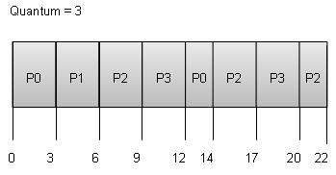

Wait time of each process is as follows −

|  |  |
| --- | --- |
| **Process** | **Wait Time : Service Time - Arrival Time** |
| P0 | (0 - 0) + (12 - 3) = 9 |
| P1 | (3 - 1) = 2 |
| P2 | (6 - 2) + (14 - 9) + (20 - 17) = 12 |
| P3 | (9 - 3) + (17 - 12) = 11 |

Average Wait Time: (9+2+12+11) / 4 = 8.5

1. **Multiple-Level Queues Scheduling**

Multiple-level queues are not an independent scheduling algorithm. They make use of other existing algorithms to group and schedule jobs with common characteristics.

* Multiple queues are maintained for processes with common characteristics.
* Each queue can have its own scheduling algorithms.
* Priorities are assigned to each queue.

For example, CPU-bound jobs can be scheduled in one queue and all I/O-bound jobs in another queue. The Process Scheduler then alternately selects jobs from each queue and assigns them to the CPU based on the algorithm assigned to the queue.

1. **Preemptive SJF**

|  |  |  |
| --- | --- | --- |
| **Process No.** | **Arrival Time** | **Burst Time** |
| A | 0 | 3 |
| B | 1 | 6 |
| C | 4 | 4 |
| D | 6 | 2 |

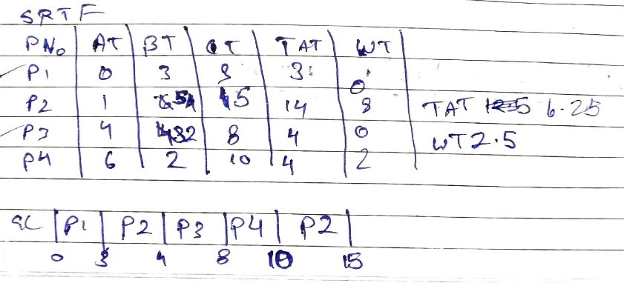

1. **Non-Preemptive SJF**

|  |  |  |
| --- | --- | --- |
| **Process No.** | **Arrival Time** | **Burst Time** |
| A | 0 | 3 |
| B | 1 | 6 |
| C | 4 | 4 |
| D | 6 | 2 |

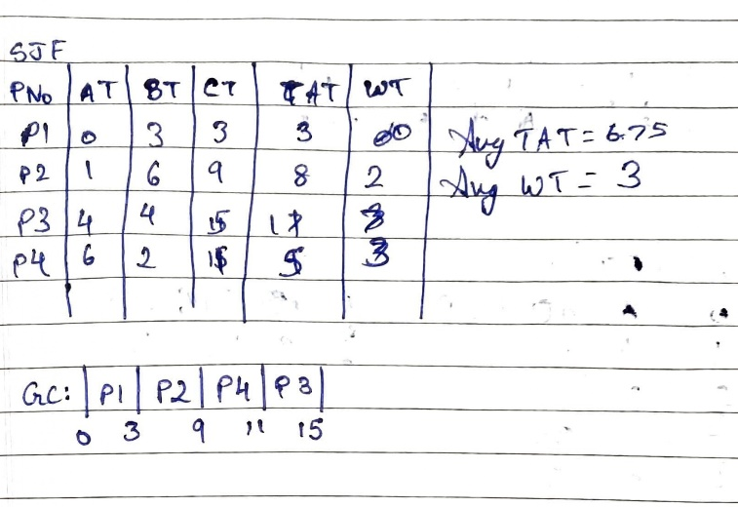

1. **Rate Monotonic Scheduling**

* Rate monotonic scheduling is a priority algorithm that belongs to the static priority scheduling category of Real Time Operating Systems.
* It is pre-emptive in nature.
* The priority is decided according to the cycle time of the processes that are involved.
* If the process has small job duration, then it has the highest priority.
* Thus, if a process with highest priority starts execution, it will pre-empt the other running processes. The priority of a process is inversely proportional to the period it will run for.

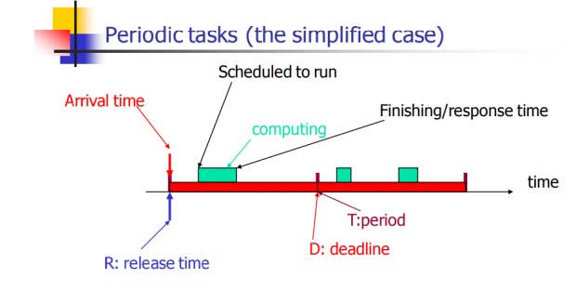

A set of processes can be scheduled only if they satisfy the following equation:

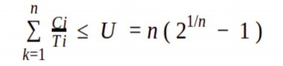

Where n is the number of processes in the process set, Ci is the computation time of the process, Ti is the Time period for the process to run and U is the processor utilization.

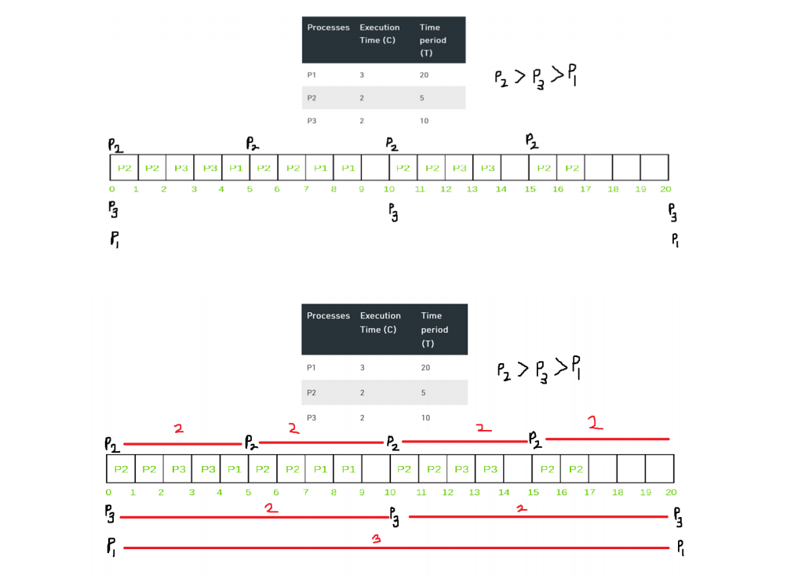

1. **Earliest Deadline First**

* Earliest deadline first (EDF) or least time to go is priority-based preemptive scheduling policy
* EDF is a dynamic priority scheduling algorithm used in real-time operating systems to place processes in a priority queue.
* Whenever a scheduling event occurs (task finishes, new task released, etc.) the queue will be searched for the process closest to its deadline.
* Job with earliest (absolute) deadline has highest priority
* Does not require knowledge of execution times
* Is known to be an optimal policy for a single processor (?)
* With scheduling periodic processes that have deadlines equal to their periods, EDF has a utilization bound of 100%. Thus, the schedulable test for EDF is:

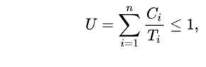

|  |  |  |  |
| --- | --- | --- | --- |
| Task | Execution Time (C) | Deadline | Time Period (T) |
| T1 | 3 | 7 | 20 |
| T2 | 2 | 4 | 5 |
| T3 | 2 | 8 | 10 |

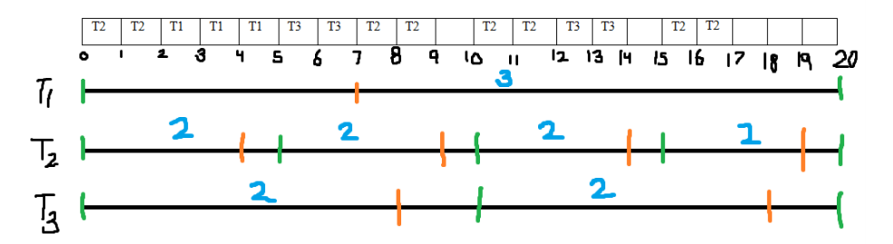

# Virtual memory Management

A computer can address more memory than the amount physically installed on the system. This extra memory is actually called **virtual memory** and it is a section of a hard disk that's set up to emulate the computer's RAM.

The main visible advantage of this scheme is that programs can be larger than physical memory. Virtual memory serves two purposes. First, it allows us to extend the use of physical memory by using disk. Second, it allows us to have memory protection, because each virtual address is translated to a physical address.

Following are the situations, when entire program is not required to be loaded fully in main memory.

* User written error handling routines are used only when an error occurred in the data or computation.
* Certain options and features of a program may be used rarely.
* Many tables are assigned a fixed amount of address space even though only a small amount of the table is actually used.
* The ability to execute a program that is only partially in memory would counter many benefits.
* Less number of I/O would be needed to load or swap each user program into memory.
* A program would no longer be constrained by the amount of physical memory that is available.
* Each user program could take less physical memory, more programs could be run the same time, with a corresponding increase in CPU utilization and throughput.

Modern microprocessors intended for general-purpose use, a memory management unit, or MMU, is built into the hardware. The MMU's job is to translate virtual addresses into physical addresses. A basic example is given below −

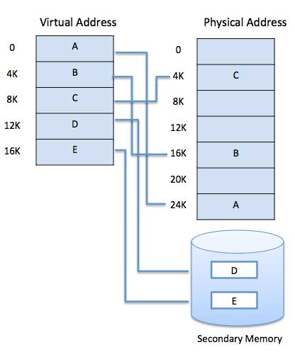

Virtual memory is commonly implemented by demand paging. It can also be implemented in a segmentation system. Demand segmentation can also be used to provide virtual memory.

## Demand Paging

A demand paging mechanism is very much similar to a paging system with swapping where processes stored in the secondary memory and pages are loaded only on demand, not in advance.

So, when a context switch occurs, the OS never copy any of the old program's pages from the disk or any of the new program's pages into the main memory. Instead, it will start executing the new program after loading the first page and fetches the program's pages, which are referenced.

During the program execution, if the program references a page that may not be available in the main memory because it was swapped, then the processor considers it as an invalid memory reference. That's because the page fault and transfers send control back from the program to the OS, which demands to store page back into the memory.

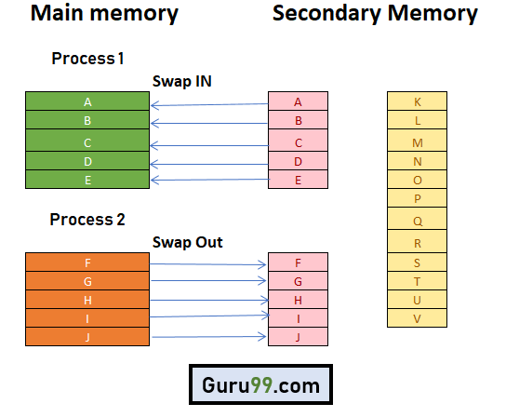

## Types of Page Replacement Methods

1. **FIFO Page Replacement**

FIFO (First-in-first-out) is a simple implementation method. In this method, memory selects the page for a replacement that has been in the virtual address of the memory for the longest time.

**Features:**

* Whenever a new page loaded, the page recently comes in the memory is removed. So, it is easy to decide which page requires to be removed as its identification number is always at the FIFO stack.
* The oldest page in the main memory is one that should be selected for replacement first.

1. Optimal Algorithm

The optimal page replacement method selects that page for a replacement for which the time to the next reference is the longest.

**Features:**

* Optimal algorithm results in the fewest number of page faults. This algorithm is difficult to implement.
* An optimal page-replacement algorithm method has the lowest page-fault rate of all algorithms. This algorithm exists and which should be called MIN or OPT.
* Replace the page which unlike to use for a longer period of time. It only uses the time when a page needs to be used.

1. LRU Page Replacement

The full form of LRU is the Least Recently Used page. This method helps OS to find page usage over a short period of time. This algorithm should be implemented by associating a counter with an even- page.

**Features:**

* The LRU replacement method has the highest count. This counter is also called aging registers, which specify their age and how much their associated pages should also be referenced.
* The page which hasn't been used for the longest time in the main memory is the one that should be selected for replacement.
* It also keeps a list and replaces pages by looking back into time.

## Advantages of Virtual Memory

* Virtual memory helps to gain speed when only a particular segment of the program is required for the execution of the program.
* It is very helpful in implementing a multiprogramming environment.
* It allows you to run more applications at once.
* It helps you to fit many large programs into smaller programs.
* Common data or code may be shared between memory.
* Process may become even larger than all of the physical memory.
* Data / code should be read from disk whenever required.
* The code can be placed anywhere in physical memory without requiring relocation.
* More processes should be maintained in the main memory, which increases the effective use of CPU.
* Each page is stored on a disk until it is required after that, it will be removed.
* It allows more applications to be run at the same time.
* There is no specific limit on the degree of multiprogramming.
* Large programs should be written, as virtual address space available is more compared to physical memory.

## Disadvantages of Virtual Memory

* Applications may run slower if the system is using virtual memory.
* Likely takes more time to switch between applications.
* Offers lesser hard drive space for your use.
* It reduces system stability.
* It allows larger applications to run in systems that don't offer enough physical RAM alone to run them.
* It doesn't offer the same performance as RAM.
* It negatively affects the overall performance of a system.
* Occupy the storage space, which may be used otherwise for long term data storage.

# Device Management Policies

A device management policy determines what a process may do to a device, and how the device behaves.

## Disk Management Policy

The disk management policy presents the operating system's view of the disk to the user process. A user process' view of the disk is the same as the operating system's view of the disk; that is, the disk appears to a user process as an C-style array of disk blocks.

This policy is known as **raw disk management**, and is important for those application, such as data-base applications, that need to control all aspects of data movement between disk and primary store.

# File Management Policies

A file is collection of specific information stored in the memory of computer system. **File management is defined as the process of manipulating files in computer system, it management includes the process of creating, modifying and deleting the files**.

The following are some of the **tasks performed by file management of operating system of any computer system**:

1. It helps to create new files in computer system and placing them at the specific locations.
2. It helps in easily and quickly locating these files in computer system.
3. It makes the process of sharing of the files among different users very easy and user friendly.
4. It helps to stores the files in separate folders known as directories. These directories help users to search file quickly or to manage the files according to their types or uses.
5. It helps the user to modify the data of files or to modify the name of the file in the directories.